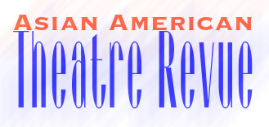


Rigg, Kate and Leah Ryan

• BIRTH OF nASIAN (Mark Taper, 2004)
Cool, hilarious and provocative, Birth of nAsian is Nuyorasian
trip hopcomedy theatre. Performer Kate Rigg brings you a
host of edgy, surreal characters from a token Asian newscaster
with a non-ethnic sounding name to a hundred year old trini to
a China-Latina with an axe to grind. Accompanied by former
classical-virtuoso-turned-rocking-electronic-violin-diva Lyris
Hung on beats, live violin, samples and soundscape, Birth is a
mix of comedy and spoken word pieces reflecting the urban
voice of Asian America.

