K A T E R I G G
SAG/AFTRA/AEA/CAEA
JKA 818 980 2093
Sullivan Talent 212-665-9516

TELEVISION
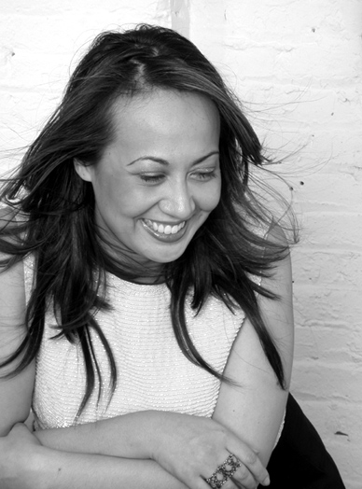
Family Guy Recurring FOX
Law & Order Recurring NBC
Race Is The Place PBS
Colorvision Host “The Date” PBS
Awesomely Bad.. Recurring VH1
Kings Of Comedy Pilot-Series Regular FOX
Wonderland Recurring ABC
Law & Order C.I. Guest Lead NBC
OZ Featured HBO
What’s New? Series Regular CBC

THEATRE
BFE Isabel Long Wharf Theater
Playwrights Horizons/Dir. Gordon Edelstein
Birth Of An Asian Various Comedy Central Theater, tour
Sez She Various Mark Taper Forum/Dir. Corey Madden
The Vagina Monologues Woman 3 Westide Theatre/Dir. Joe Mantello
Dogeaters Rio NYSF-Public Theatre/Dir. Michael Greif
Lasians Amber ATW/Center Theater Group/Dir. Chay Yew
"A Modern Lenny Bruce"

- San Francisco Bay Guardian
The Most Fabulous Story Jane/u/s Various Minetta Lane Theatre/Dir. Christopher Ashley
Hair of the Dog Dale Clark Studio Theatre/Dir. Marsha Norman

Kate’s Chink-O-Rama Various NYC Fringe;NYSF/Joe’s Pub;BRAVA SF
Wilder Rediscovered Daphne/Lady Sibyl Actors Th. of Louisville/Dir. Tazewell Thompson
As You Like It Phebe Playmaker’s Rep/Dir. Tazewell Thompson
"A Star on the Manhattan Comedy Scene...In Your Face Slanted"

-TIME Magazine

COMEDY APPEARANCES
NBC Late Night Friday Featured Comic NBC
CTV Comedy Now! Featured Comic CTV/The Comedy Network
Star TV Profile, Self City TV, STAR TV (Canada)
"Funny and ferociously
energetic…versatile character work by Rigg…at full throttle, an urban machine"

- San Francisco Chronicle
VH1 Comic/ Self “Awesomely Bad”
SEX TV Asian Sexuality Special

Comedy Central “Women in Comedy”

STAND UP

Toyota Comedy Festival Montreal Comedy Festival Caroline’s Comedy Club
Gotham Comedy Club Boston Comedy Club Laugh Factory
Improv LA Improv Irvine Vancouver International Comedy
"Truly a force to be reckoned with - outrageously funny song parodies, characterizations, political satire, rap… and the very fly Chinkorama dancers"
- Backstage Magazine

Also: lead vocals/lyrics for the band “Slanty Eyed Mama”

TRAINING
The Juilliard School Dip Acting
British American Drama Academy/Oxford
GRANTS/AWARDS
NEA commission “Urban Tao”; Asian Women’s Giving Circle “Americasiana”; Urban Arts
Initiative “Americasiana”; Juilliard Interarts Award “m/OTHER/land”; NYFA Fellow ’05; Dixon
Place Mondo Cane commission; Jerome Foundation “Birth of a nASIAN”; Canada Council
“m/OTHER/land”; Ludwig Vogelstein Grant “Urban Tao”.

